Pwd : Present Working Directory
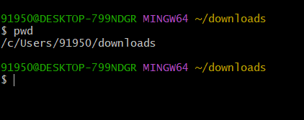
ls : list of all files and Directories
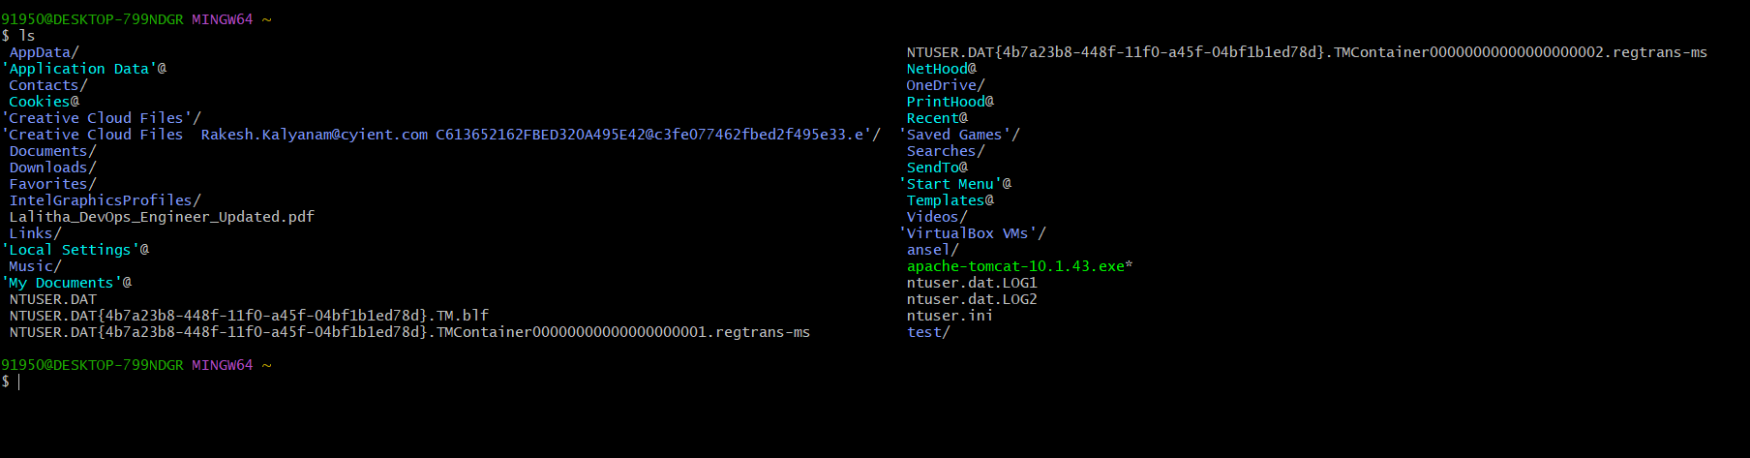
mkdir : creates a new Directory
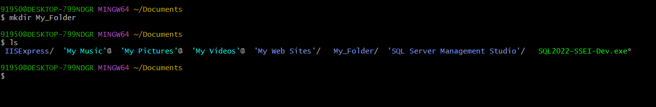
ls -l : list files in long format
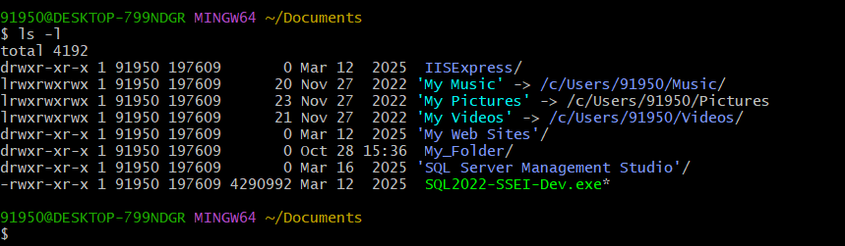
ls -a : list all files including Hidden Files

Cd : moves to the home Directory
cd Documents : Moves into the Documents Folder
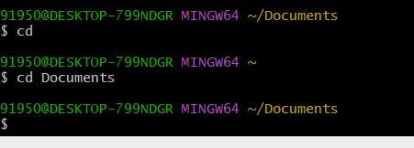
cd .. : This Moves one step back in the directory
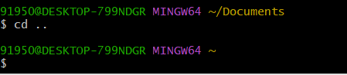
Cd / : Moves to the Root Directory
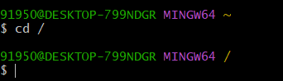
cd ~ : Moves to the Home Directory
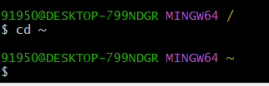
mkdir : Creates a New Directory
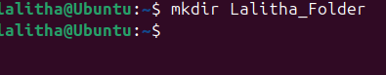
rmdir : Deletes an Empty Directory
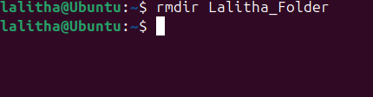
touch file.txt : Creates an empty file
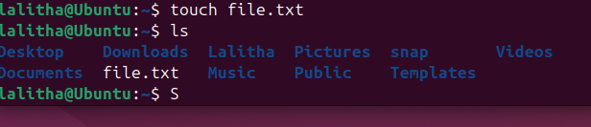
ls -ls : list of files in sorting format
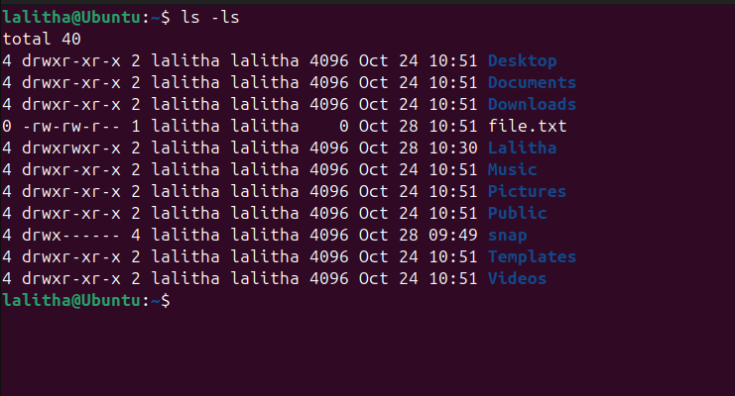
ls -d */ : list all the directories only
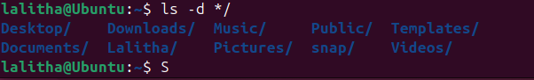
Cd ../.. : Two step back
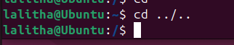
ll : Complete Details of Every File
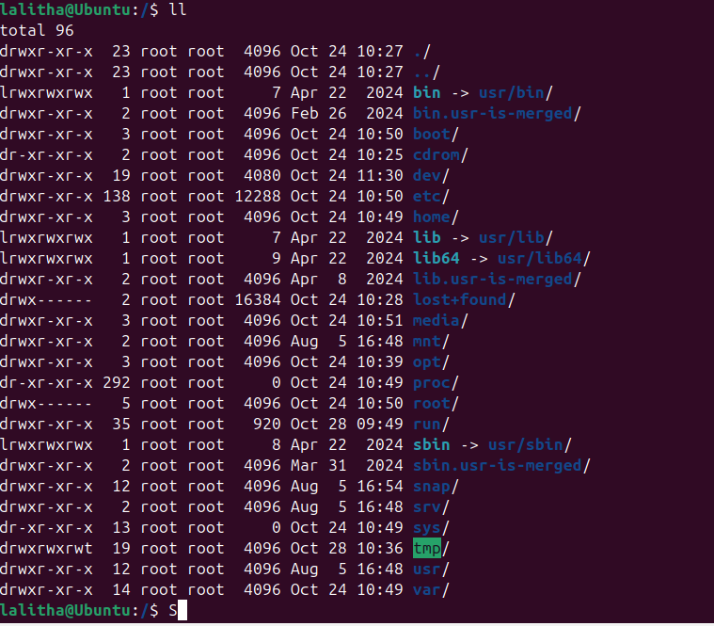
ls -ltr : (list acoordingly to time ) complete Details
